**Adverse News Screening for Financial Crime Surveillance**

**Objective**

To develop a dashboard to automatically screen publicly available news articles and identify entities (individuals or corporations) potentially involved in financial crime, scandals, or sanctions. Below are the steps and methodology taken to create the dashboard.

**Data Source**

Ideally, we would like to extract news articles from reputable financial news website such as:

* Bloomberg
* Wall Street Journal
* Reuters
* Financial Times

However, these websites are usually not free (subscription based, articles behind paywall). The official APIs are subscription based too. As such, one more reliable and reputable website used for this project is Consumer News and Business Channel (CNBC), a financial and business website that is mostly unbiased (no political leaning) with numerous free articles.

News articles published between Oct 2024 to Jan 2025 were extracted from CNBC for this project; a total of 3324 articles have been downloaded.

**Data Preparation**

Named Entity Recognition (NER) was performed to identify entities that are people or organization within the news article. This was accomplished using SpaCy, a fast and easy to use library, in Python. SpaCy is associated with the SpaCy_Entity_Linker library, which makes it easier to merge labeled entities from SpaCy to entities and their Wikipedia URL created with SpaCy_Entity_Linker.

One issue with SpaCy is that output entities are not standardised; using this example below, SpaCy can either return ‘Mark Zuckerberg’ or ‘Zuckerberg’, depending on the what was written in the news article. Hence for each distinct Wikipedia URL, the entity form that occurs the most will be used to represent that entity, i.e. if ‘Mark Zuckerberg’ is 20 times while ‘Zuckerberg’ only 5 times out of all 25 occurrences, ‘Mark Zuckerberg’ will be used as the entity label for this Wikipedia URL.

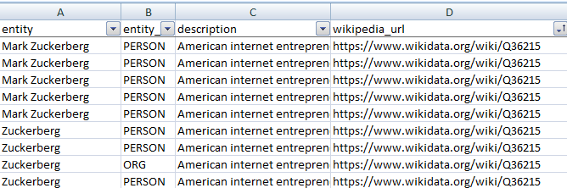

**Adverse News Classification Methodology**

In order to classify whether news article contains adverse news related to financial crimes, scandals or sanctions, Machine Learning (ML) model would be built to handle this task. There are several possible approaches to creating the ML model:

1. Manually label news article by their topic and train ML model with them: This is labour intensive, especially if there are many categories of financial crimes required to be detected in the news.
2. Use pre-trained ML models to do the classification: there are many Large Language Models on Hugging Face that can handle natural language processing and classify the news based on its text content.

With the various pre-trained models available, there are few possible ways to do the classification:

1. Adverse news can be considered as negative sentiment, thus we can use sentiment classification model to classify adverse news
2. Defining possible financial crime categories and inputting them into zero shot classification models
3. Can also input categories [‘positive’, ‘neutral’, ‘negative’] to zero shot classification model to do sentiment classification

We will be using both method A and B to identify adverse financial crimes as it is possible article could mention something crime related but the sentiment is positive, see given example below:

*U.S. blockchain startup Ripple launches new services aimed at helping banks and fintech firms store digital assets. New features include pre-configured operational and policy settings, monitoring of anti-money laundering risks, and a new user interface that's easier to use and engage. The move will help Ripple diversify beyond its core payment settlement business. The crypto custody market is forecast to reach at least $16 trillion by 2030, according to the Boston Consulting Group. It counts the likes of HSBC, the Swiss arm of BBVA, Societe Generale and DBS as clients.*

This would be labeled anti-money laundering by zero shot classification model but positive sentiment by sentiment classification model. Since this is about a company Ripple adding features to prevent anti money laundering, no crime is involved and Ripple would not be a focus to DBS. Hence, the need to have a sentiment classification model trained alongside model for topic modeling.

**Models**

Pre-trained models from Hugging Face were used for classification. They were selected based on their usage (most likes/downloads) as well as whether they were trained on financial related datasets.

|  |  |
| --- | --- |
| Sentiment Classification | Zero Shot Classification |
| ProsusAI/finbert | facebook/bart-large-mnli |
| yiyanghkust/finbert-tone | MoritzLaurer/DeBERTa-v3-base-mnli-fever-anli |
| mrm8488/distilroberta-finetuned-financial-news-sentiment-analysis |  |

All the models have maximum token input of 514 tokens, so news articles shall be summarised first with pre-trained summarization model "sshleifer/distilbart-cnn-12-6" before inputting to model. However another constrain is introduced as summarization model only allows for 1024 token input, hence for long news article, text needs to be split into smaller body of text.

For news article that have been chunked into a few sections to classify, multiple labels would be obtained for every chunk. The final label for that article would be based on majority vote from all the chunks and final score would be calculated as the average score of the majority label.

**Model Selection and Validation**

As the CNBC news extracted does not have any labels on sentiment or the topic, and a lot of effort would be needed to label all 3324 articles, the steps below would be used to select and validate best model to be used:

* Create a small labeled dataset and fit into, for example, all possible sentiment classification models
* Evaluate models based on their precision, recall and f1 score
* Use best sentiment model to fit CNBC news dataset
* Randomly sample some articles from CNBC news dataset and check the predicted labels against the article (does the predicted label make sense)

**Final modeling Steps**

1. Load CNBC news dataset
2. Chunk articles that are too long to fit summarisation model, else fit article to summarisation model to get text with max 514 tokens
3. Fit summarised text to best sentiment classification model
4. Fit summarised text to best zero shot classification model

**Financial Crime Topic Modeling Results**

For financial crime topic modeling, a dataset with 75 news article was extracted from various news sources and labeled as ‘fraud’, ‘tax evasion’ and ‘non financial crimes’. Categories to classify the articles into were: ‘fraud’, ‘scam’, ‘tax evasion’, ‘other financial crimes’ and ‘non financial crimes’.

Below tables show the recall, precision and accuracy of the models used:

With the exception of the recall for tax evasion (refer to boxes highlighted in red), the MoritzLaurer/DeBERTa-v3-base-mnli-fever-anli generally performed better in terms of precision, recall and f1-score for all labeled categories. Overall accuracy was a bit higher than facebook/bart-large-mnli at 67%. MoritzLaurer/DeBERTa-v3-base-mnli-fever-anli would thus be used for topic modeling of financial crime on the CNBC news dataset.

**Sentiment Classification Model Results**

The same dataset of 75 news articles from the topic modeling experiment was used but now articles are manually labeled as negative, neutral or positive

Tables below show the recall, precision and accuracy of the models used.

ProsusAI/finbert outperformed the rest of the models in all metrics, with overall accuracy at 73%. ProsusAI/finbert will be used for sentiment classification.

**CNBC results**

Attached below is the excel file containing samples of CNBC news predicted with ProsusAI/finbert model for sentiment classification and MoritzLaurer/DeBERTa-v3-base-mnli-fever-anli for financial crime labeling.



Based on human interpretation of the articles, it seemed the models correctly predicted about 16 out of 24 articles (~67%). Perhaps as ProsusAI/finbert is trained for financial sentiment classification and CNBC contains other types of news such as politics, the sentiment classification might not be as good. The financial crime topics might also be too few hence model misclassifies certain crimes such as bribery to fraud.

**Relevance Scoring Methodology**

A relevance score would be created in order to quantify how relevant the news is to financial crime.

A possible calculation is:

*Reputation of News website * financial crime score from model * sentiment classification score from model*

Where:

**Reputation of news website:** Take values 1 to 10 inclusive, where 10 is most reputable and 1 is least reputable.

**Financial crime score from model:** Takes value 0 to 1, where 1 is most likely to belong to that crime. If the topic belongs to non financial crime, set this score to 0.

**Sentiment classification score:** Takes -1 to 1, where news that are classified as positive shall take the negative of score from sentiment classification model, news that are neutral shall take 0.5 * score from sentiment classification model and news that are negative shall take actual score from sentiment classification model.

As there is only one news source used now, for this project the reputation score portion was not used in the calculation. The final relevance score would take values between -1 to 1, where larger and more positive value are news that are highly relevant to adverse financial crime.

Since there is a sentiment classification model that predicts sentiment label for the news, another way to get relevant adverse financial crime news would be to filter for only news articles that have negative sentiment label first and apply the same calculation, as positive and neutral news are likely not of interest to stakeholder.

**Financial Crime Dashboard and its Business Value**

The predicted results from the model for the news article would be stored and displayed in a dashboard for user to monitor financial crimes around the world so that the bank is aware of such events happening to update watchlist of people or organizations mentioned, or learn from others’ mistakes and review policies and workflows to reduce risks of similar situation occurring.

With a dashboard, user can identify trends as well as drill down into points of interest in the data. The dashboard is displayed on the next page. Tableau dashboard can be found [here.](https://public.tableau.com/views/financialcrimedashboard/Dashboard1?:language=en-US&:sid=&:redirect=auth&:display_count=n&:origin=viz_share_link)

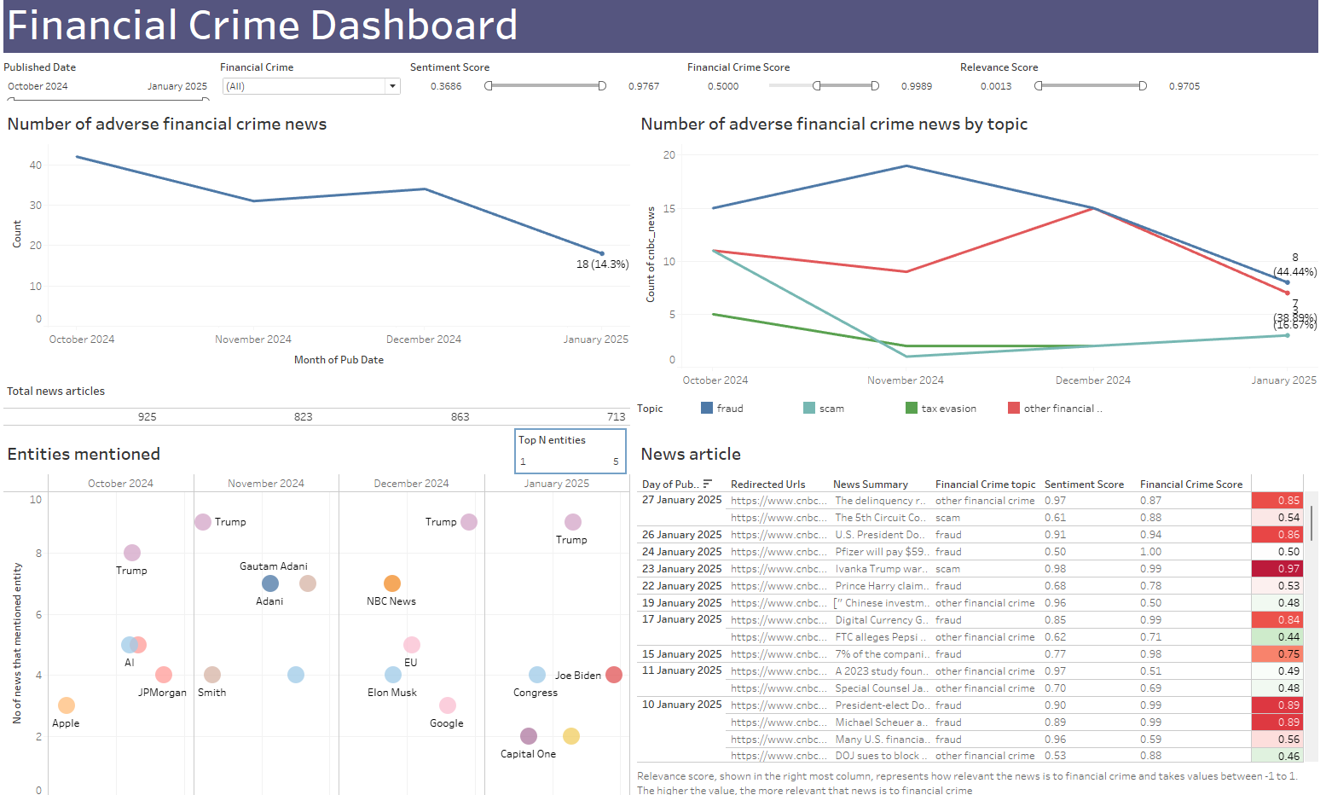

Below describes possible analysis that can be done with the Dashboard:

1. From the dashboard, we can observe that adverse crime news have been decreasing since Oct 2024, with fraud related crimes usually forming the majority. There seemed to be a high number of fraud cases in Nov 2024; user can click the fraud data point in Nov 2024 to zoom in on entities mentioned and news articles on fraud in that period. There is a number of mentions on Gautam Adani and Adani, user can highlight these 2 circles to further filter for news articles relating to them.

Based on the news summary, Adani Group and their Group Chair Gautam Adani were allegedly involved in an extensive bribery and fraud scheme, with the bribes paid to obtain solar energy contracts. With this info, DBS which has a presence in India, might need to closely monitor transaction activities of persons tied to Adani Group as well as loans and transactions of solar energy companies in India with DBS to freeze suspicious accounts and transactions for investigations.

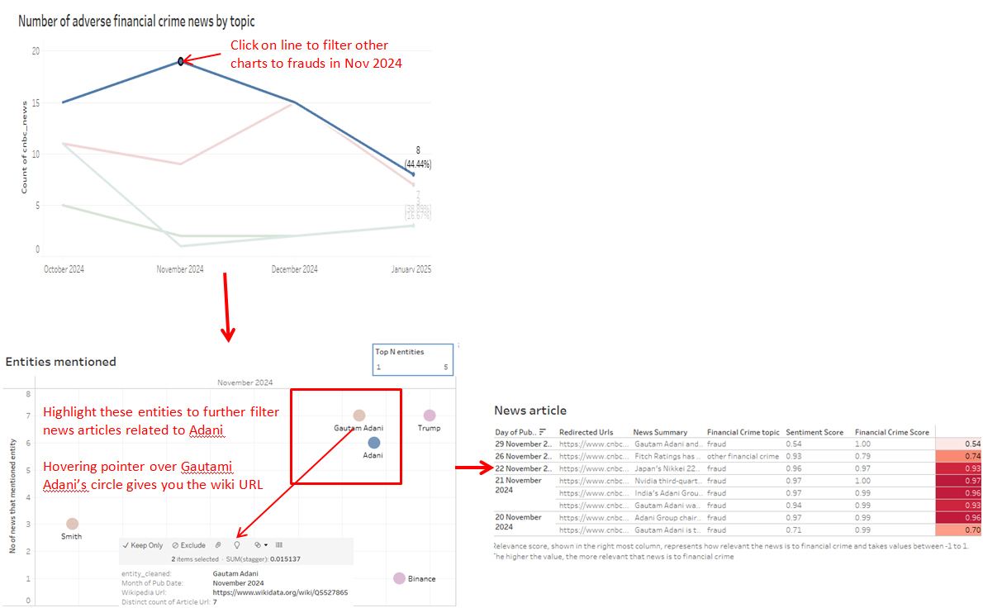

1. User can filter for relevance score more than 0.9 to get news articles that are more relevant to financial crimes. They can then read through the news summary to determine if any actions need to be taken by the bank. For example, the first article in the list reported that fake crypto coin called $IVANKA was being promoted and posed risks to investors. DBS could consider putting up a warning to customers who are transferring monies to crypto exchanges to be wary of fake crypto coins circulating to increase awareness. DBS could also engage relationship managers to inform clients the risks of investing in $IVANKA.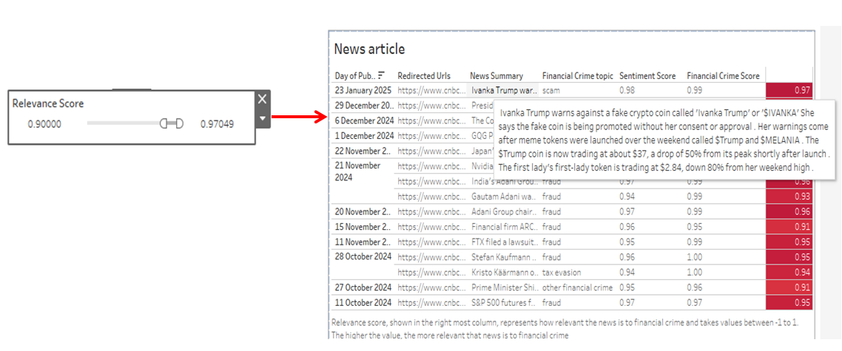

**Challenges**

Data Source:

Many reputable financial websites are subscription based platform so articles are behind paywalls. A workaround would be to source for websites that have articles that are mainly free, however, they might not be as credible as reputable news sources.

Scraping/Downloading:

Official APIs are not free and open source libraries have various limitations (limited historical period, limited articles pulled per request, limited requests per day, sending too many queries could trigger blocking etc.) Possible workarounds:

* + Spread out the queries over many days, add delay between queries with time.sleep(). However this would result in a long time extracting the articles.
  + Subscribe to official news website APIs which will incur costs. This would be the best option if having a financial crime dashboard for surveillance is beneficial for DBS in the end

Models:

Summarisation model have max limit of 1024 tokens that can be inputted to model, hence there is still a need to shorten text by chunking first before summarising

* + Workaround: Paid subscription of Gen AI APIs, like Open AI API, have higher token limits. Can do prompt engineering to summarise the news article instead for future enhancement

**Future Enhancements**

Label Categories:

Certain news article can be about more than 1 topic, e.g. XXX company convicted of fraud and tax evasion. Currently each article is only given 1 topic label. This would affect the model validation result in model selection process. For future enhancements, would need to manually label articles with multiple financial crime topic if required. Similarly from model, if predicted topic have score of more than 0.75 for example, assign those topics to the article too.

Only certain topics are manually labelled to test and validate pre trained models in the interest of time. Can extract more news articles related to other financial crimes to check if model is able to correctly predict those topics too, and whether the final model selected is still the same.

Entity Linking:

SpaCy Entity Linker library is not the most accurate library, with no context sensitivity due to the implementation of the "max-prior method" for entitiy disambiguation. Can consider exploring other packages such as BLINK to do entity linking instead. Then to match back the entity and their Wikipedia links to entity with NER labels, fuzzy matching might need to be done.

Models:

Can consider doing transfer learning to see if model results will improve. While current pre trained models selected seemed to be performing well, perhaps training on specific financial news articles might give better results.

Dashboard:

User now has to read through each individual news article if there are a few articles related to user’s filter condition (for example, the Adani case scenario). This is still a lot of work for user to analyse if any actions are needed to be taken by the bank. Perhaps another system, such as a UI to let user upload all articles in to summarise them could be put in place. This would have Open AI or Gemini at backend taking in the prompt to summarise all articles sent to it and outputting a summary of all articles back for user.

Sanction lists data were not included in this project. One possible use could be to have a chart/table highlighting new persons or organizations added or removed from the list in the latest month so that user will be up to date on any changes